

**GSCA 2018 International Conference and Trade Show**

**Film Descriptions**

**NEW FILMS**



**America’s Musical Journey**

**Presentation:** Tennessee Aquarium: 3D; Dome Day at McWane Science Center: 15/70  
**Release:** February 16, 2018  
**Formats:** 2D and 3D, 15/70, DCI-compliant Digital, DCI-compliant Laser, IMAX Digital, IMAX Laser, Dome-customized 15/70, Fulldome Digital  
**Length:** 39:57  
**Producer/Distributor:** MacGillivray Freeman Films  
**Distributor:** MacGillivray Freeman Films  
**Contact:** Patty Collins, [pcollins@macfreefilms.com](mailto:pcollins@macfreefilms.com)  
[americasmusicaljourney.com/](http://americasmusicaljourney.com/)

*America’s Musical Journey* celebrates the unique diversity of cultures and creative risk-taking that characterize America, as told through the story of its music. Follow Grammy Award®-nominated singer/songwriter Aloe Blacc as he traces the roots of America’s music and follows the footsteps of Louis Armstrong through the colorful locales where American music was born. Visiting cities such as New Orleans, Chicago, New York, Nashville, Memphis, Miami, and more, audiences will experience paddle-wheeling up the Mississippi Delta, flash mob dancing in Chicago, and skydiving with Elvis impersonators in scenes shot exclusively for the giant screen. Along the way, they’ll discover the unique collision of cultures that gave birth to America’s music, culminating in a one-of-a-kind blend of sound, culture and innovation unlike anywhere else in the world. A MacGillivray Freeman film produced in association with Brand USA and presented by Expedia, and Air Canada.

**Apollo 11: First Steps**

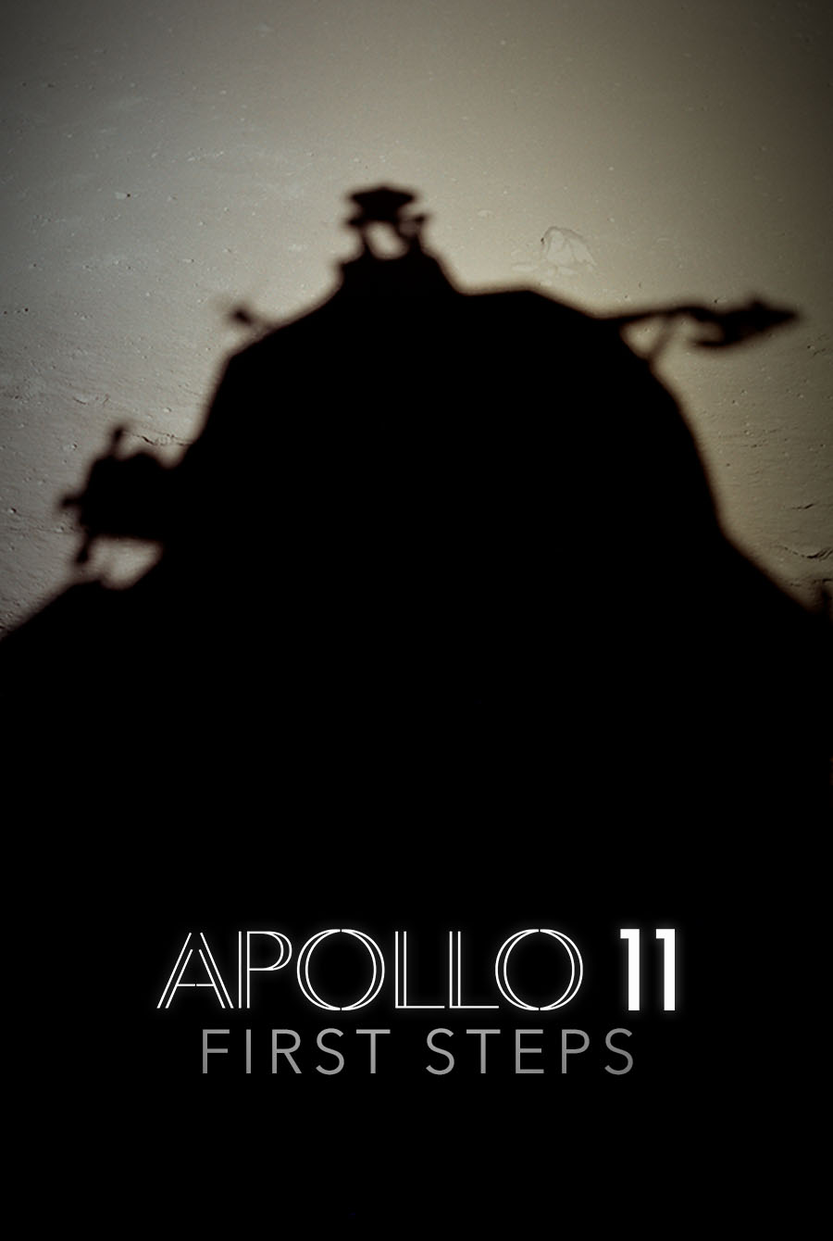

Rough/fine cut  
**Presentation:** Tennessee Aquarium: 2D  
**Release:** Spring 2019  
**Formats:** 2D, 15/70, DCI-compliant Digital, DCI-compliant Laser, IMAX Digital, IMAX Laser, Dome-customized 15/70, Fulldome Digital  
**Length:** 40:00  
**Producer:** Statement Pictures  
**Distributor:** To be determined  
**Contact:** Tom Petersen, [tpetersen@statementpictures.com](mailto:tpetersen@statementpictures.com)

Timed for release around the 50th anniversary of the first lunar landing, *Apollo 11: First Steps* gives a thrilling, direct-cinema experience of NASA’s historic Apollo 11 mission. With the assistance of NASA, National Archives, and a global team of researchers, the filmmakers have unearthed a treasure trove of never-before-seen footage and audio recordings to reconstruct the mission in astonishing detail. Told primarily with archival materials, the film puts audiences back in 1969 when the world united to watch man’s first steps on the moon. From the Emmy® Award-winning filmmakers of *Dinosaur 13*in partnership with CNN Films, *Apollo 11: First Steps* will premiere in Spring 2019.

**Australia’s Great Wild North**

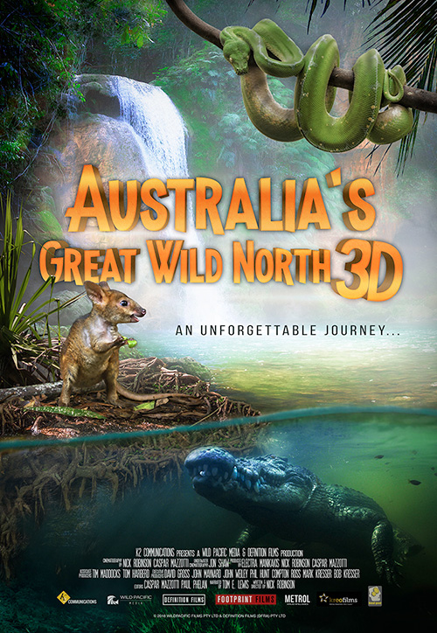

**Presentation:** Tennessee Aquarium: 2D; Dome Day at McWane Science Center: 15/70  
**Release:** June 28, 2018  
**Formats:** 2D, 15/70, DCI-compliant Digital, DCI-compliant Laser, IMAX Digital, IMAX Laser, Dome-customized 15/70, Fulldome Digital  
**Length:** 41:10 and 25:00  
**Producer:** Wild Pacific Media and Definition Films  
**Distributor:** K2 Communications  
**Contact:** Mark Kresser, mark_kresser@k2communications.com  
[www.k2communications.com](http://www.k2communications.com)

Few places on earth remain as wild and pristine as the Top End of Australia. It is a land that time forgot. A place with some of the richest wetlands and oldest rainforests where ancient people lived in harmony with this wild land and her beasts. The largest dinosaurs called this land home and left their foot prints in these ancient rocks, and one of their deadly relatives still lives there today. Come on this epic scientific adventure with Tommy, our native Aboriginal guide, as we venture through some of the world's most beautiful landscapes, and travel deep into saltwater crocodile country.

**Backyard Wilderness**

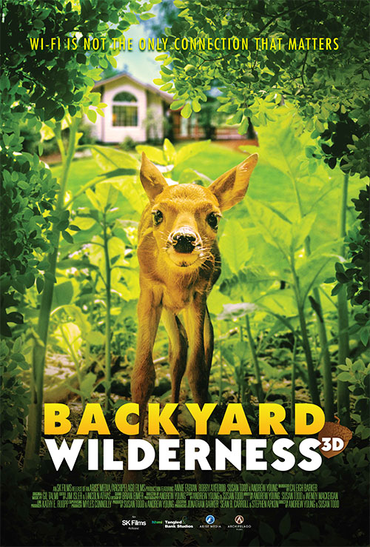

**Presentation:** Tennessee Aquarium: 3D; Dome Day at McWane Science Center: 15/70  
**Release**: March 21, 2018  
**Formats**: 2D and 3D, DCI-compliant Digital, DCI-compliant Laser, IMAX Digital, IMAX Laser, Dome-customized 15/70, Fulldome Digital  
**Length**: 42:59 (short version also available)  
**Producer**: Arise Media and Archipelago Films  
**Distributor**: SK Films  
**Contact**: Amber Hawtin, [ahawtin@skfilms.ca](mailto:ahawtin@skfilms.ca)  
[www.backyardwildernessfilm.com](http://www.backyardwildernessfilm.com)

*Backyard Wilderness*will astound and entertain viewers with the unexpected wonders of nature that are right under our noses: in our own backyards. Spanning a seasonal year around a suburban home, the film displays a stunning array of unique wildlife images and behavior. Captured by cameras mounted inside dens and nests, and moving along the forest floor and pond bottom, we reveal the lives of its inhabitants in rare and breathtaking intimacy. We follow Katie, a young girl, and her modern family living next to the woods who are blind to the real-life spectacle around them, absorbed by an array of electronic devices in their busy lives. Katie gradually discovers the intricate secrets that nature has hidden so close to her front door and we experience the joy she finds in her interactions with this new world. The film reminds us that Wi-Fi is not the only connection that matters and that, sometimes in ordinary places, you can uncover extraordinary things that could transform you forever. You just need to step outside.

**Cuba**

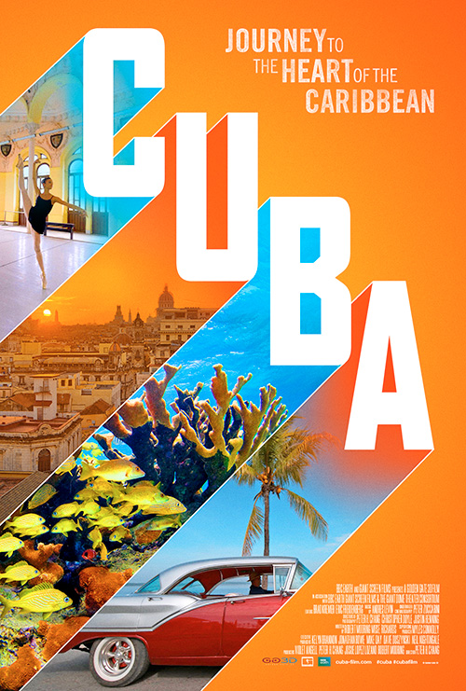

**Presentation:** Tennessee Aquarium: 2D  
Release: 2019  
**Formats:** 2D and 3D, 15/70, DCI-compliant Digital, DCI-compliant Laser, IMAX Digital, IMAX Laser, Dome-customized 15/70  
**Length:** 20:00 and 40:00 (40:00 in Chattanooga)  
**Producer:** Golden Gate 3D in association with BBC Earth and Giant Screen Films  
**Distributor:** Giant Screen Films and BBC Earth  
**Contact:** Mark Katz, [mkatz@gsfilms.com](mailto:mkatz@gsfilms.com)

*Cuba* tells the powerful story of a land preserved in time yet poised today on the cusp of dramatic change. Through the eyes of Cuban artists, historians, and marine biologists, audiences will have a rare opportunity to explore this amazing country at a pivotal moment in its history. Produced in association with the Giant Dome Theater Consortium and BBC Earth.

**Great Barrier Reef**

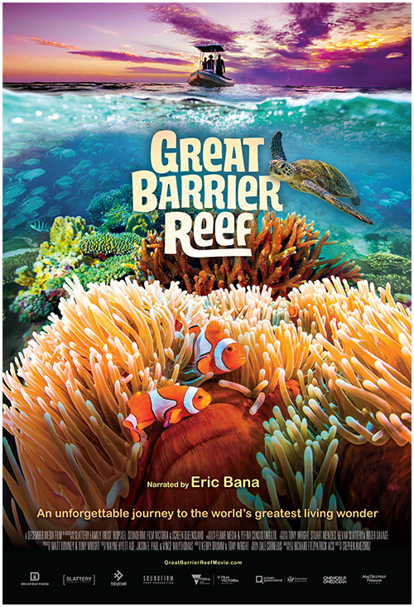

**Presentation:** Tennessee Aquarium: 3D; Dome Day at McWane Science Center: 15/70  
**Release:** July 1, 2018  
**Formats:** 2D and 3D, 15/70, DCI-compliant Digital, DCI-compliant Laser, IMAX Digital, IMAX Laser, Dome-customized 15/70, Fulldome Digital  
**Length:** 40:00  
**Producer:** December Media  
**Distributor:** MacGillivray Freeman Films  
**Contact:** Patty Collins, [pcollins@macfreefilms.com](mailto:pcollins@macfreefilms.com)  
[www.greatbarrierreefmovie.com](http://www.greatbarrierreefmovie.com)

No structure built by living creatures compares to the size and majesty of the Great Barrier Reef—spanning more than 1,400 miles off the coast of Australia and home to countless unique species of aquatic life. Narrated by acclaimed Australian actor Eric Bana, *Great Barrier Reef* explores the awe of this natural environment and introduces the visionaries and “citizen scientists” who help us better understand and protect the reef. Grab your mask and snorkel and join an unforgettable adventure with majestic manta rays and sea turtles, witness the birth of baby seahorses, participate in a coral watch expedition, and discover the exotic splendor of fluorescent corals at night as *Great Barrier Reef* captures the natural beauty and exquisite strangeness of this awesome and vibrant living world. A December Media film produced in association with Slattery Family Trust, Biopixel, Soundfirm, Film Victoria, and Screen Queensland and distributed by MacGillivray Freeman Films.

**Great Bear Rainforest**

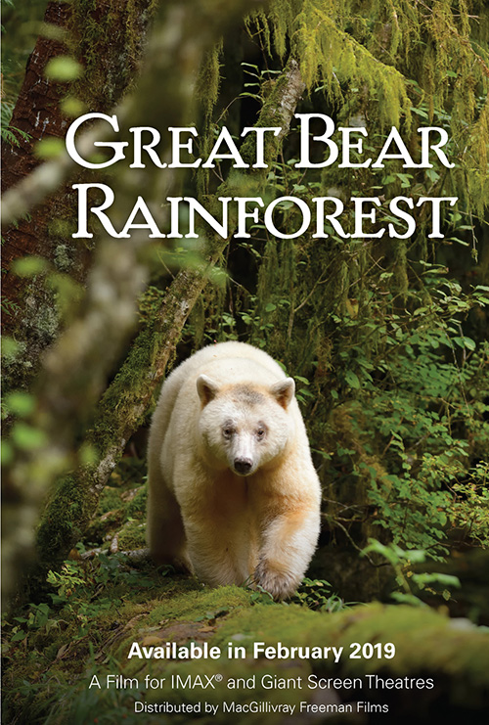

Rough/fine cut  
**Presentation:** Tennessee Aquarium: 2D  
**Release:** February 2019  
**Formats:** 2D and 3D, 15/70, DCI-compliant Digital, DCI-compliant Laser, IMAX Digital, IMAX Laser, Dome-customized 15/70, Fulldome Digital  
**Length:** 40:00  
**Producer:** Spirit Bear Entertainment  
**Distributor:** MacGillivray Freeman Films  
**Contact:** Patty Collins, [pcollins@macfreefilms.com](mailto:pcollins@macfreefilms.com)  
[greatbearrainforestfilm.com](http://greatbearrainforestfilm.com)

Filmmakers Ian McAllister and Jeff Turner and Executive Producers Kyle Washington and Byron Horner of Spirit Bear Entertainment are partnering with MacGillivray Freeman Films to distribute a beautiful giant screen film about one of the rarest animals on Earth—the fabled all-white Spirit Bear. These remarkable creatures live in the lush temperate rainforests of British Columbia on Canada's West Coast, where they hold almost mythic status among the region's indigenous people. Shot exclusively for the giant screen, *Great Bear Rainforest* will offer a remarkable journey into one of the planet's most spectacular wildernesses—a land of wolves, grizzly bears, humpback whales, sea lions, sea otters, and others—as it explores the secret world of the Spirit Bear.

**Hidden Pacific**

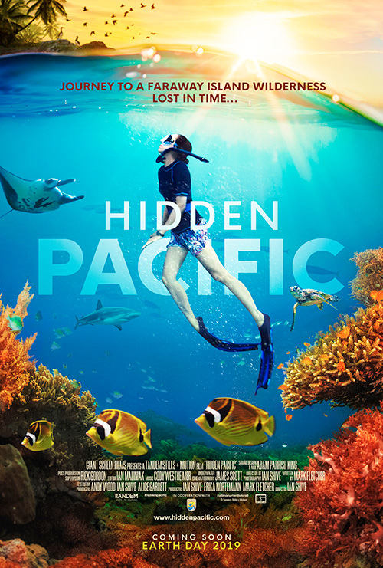

Rough/fine cut  
**Presentation:** Tennessee Aquarium: 2D  
**Release:** 2019  
**Formats:** 2D and 3D, 15/70, DCI-compliant Digital, DCI-compliant Laser, IMAX Digital, IMAX Laser, Dome-customized 15/70  
**Length:** 40:00 and 20:00 (40:00 in Chattanooga)  
**Producer:** Tandem Stills + Motion and Giant Screen Films  
**Distributor:** Giant Screen Films  
**Contact:** Mark Katz, [mkatz@gsfilms.com](mailto:mkatz@gsfilms.com)

*Hidden Pacific*will bring the Pacific Ocean’s protected and remote national wildlife refuge islands and marine national monuments to giant screen cinemas. The film captures the beauty of these emerald islets, the conservation efforts to restore their ecosystems, and the diversity of life on both land and reef. Produced in association with Tandem Stills + Motion and the U.S. Fish & Wildlife Service.

**Hurricane**

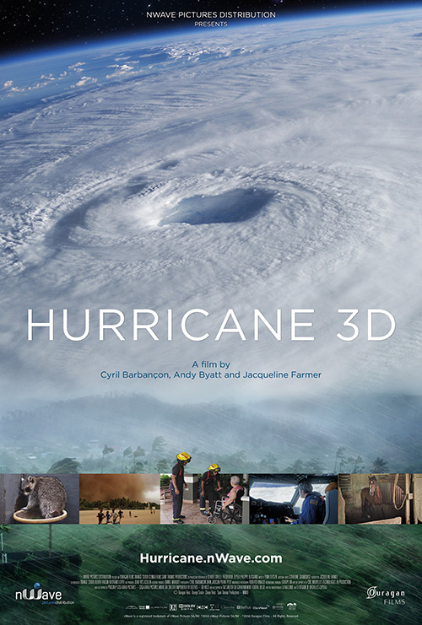

**Presentation:** Tennessee Aquarium: 3D  
**Release:** 2017  
**Formats:** 3D, DCI-compliant Digital, DCI-compliant Laser, IMAX Digital, IMAX Laser, Fulldome Digital  
**Length:** 39:51 and 22:21 (22:21 to screen at conference)  
**Producer:** Ouragan Films  
**Distributor:** nWave Pictures Distribution  
**Contact:** Janine S. Baker, Goedele Gillis, [info@nwave.com](mailto:info@nwave.com)  
[hurricane.nwave.com](http://hurricane.nwave.com/)

This is the true story of a 15,000-kilometre journey in the footsteps of one of the most devastating natural events on our planet: the Atlantic Hurricane. Our protagonist is both shatteringly destructive and vital to life on earth. A mere breeze at its conception, as it sweeps over the African Sahel it becomes a life-giving monsoon, before setting out across the Atlantic as a deepening depression. The hurricane is the film’s main character. The supporting cast—the men, women, plants, and animals that it encounters on its journey and affects in some way, for better or for worse. Serene and exquisitely beautiful from space, at ground level in the face of the screaming wind, Hurricane is nothing less than terrifying.

**In Saturn’s Rings**

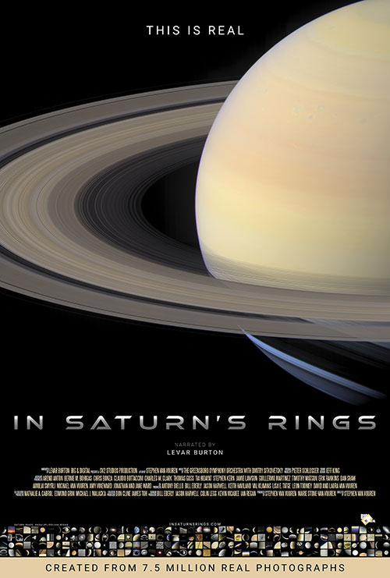

**Presentation:** Tennessee Aquarium: 2D; Dome Day at McWane Science Center: Digital  
**Release:** May 4, 2018  
**Formats:** 2D, DCI-compliant Digital, DCI-compliant Laser, IMAX Digital, IMAX Laser, Fulldome Digital  
**Length:** 39:30  
**Producer:** SV2 Studios  
**Distributor:** BIG & Digital  
**Contact:** Tina Ratterman, [tratterman@biganddigital.com](mailto:tratterman@biganddigital.com)  
[www.insaturnsrings.com](http://www.insaturnsrings.com)

Narrated by LeVar Burton, *In Saturn’s Rings* is a grand tour of the universe starring Saturn. 7.5 million real images images from the Cassini-Huygens Mission to Saturn, Sloan Digital Sky Survey, Hubble Telescope and Milky Way time lapses are brought to life in a ground-breaking and immersive journey from the earliest images after the Big Bang to the final photographs Cassini took before plunging into Saturn’s clouds. *In Saturn’s Rings* is, like space exploration itself, a journey of the heart, mind and spirit that moves audiences with awe-inspiring images and powerful music. A 25-minute film will be released in Fall/Winter for 4K/8K Digital Flat and Fulldome Theaters in DCI-Compliant and IMAX Digital/Laser formats.

**Mountain Quest**

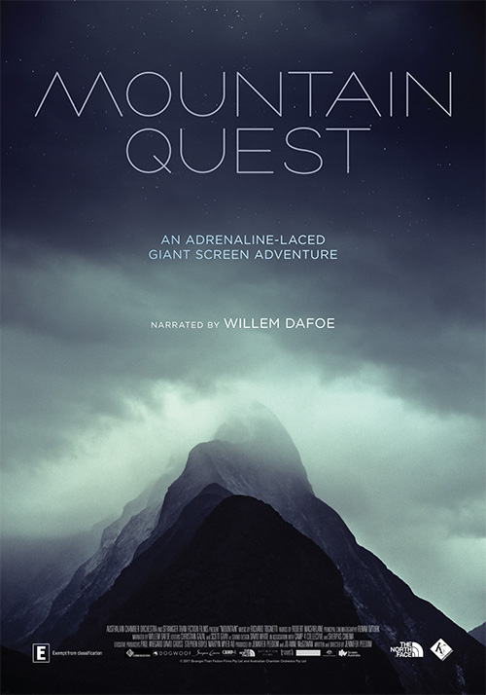

**Presentation:** Tennessee Aquarium: 2D  
**Release:** June 18, 2018  
**Formats:** 2D, 15/70, DCI-compliant Digital, DCI-compliant Laser, IMAX Digital, IMAX Laser, Fulldome Digital  
**Length:** 38.21  
**Producer:** Stranger Than Fiction Films  
**Distributor:** K2 Communications  
**Contact:** Mark Kresser, [mark_kresser@k2communications.com](mailto:mark_kresser@k2communications.com)

A lone climber, suspended hundreds of feet in the air, struggles to find the next finger hold, defining progress in inches. The dramatic visuals immerse us in a gripping contest of human determination versus the reality of gravity’s potent grip. *Mountain Quest* explores the precarious relationship of humanity’s quest to scale some of the world’s highest places, while also revealing the scientific and technological advances that have enabled us to conquer these peaks, exposing the heartbeat of the human soul. A tapestry of jaw-dropping action, combined with rich STEM content. For example, physics of the real world—how climbing is a tug-of-war between friction and gravity, while skiing involves the same battle of forces in reverse. Educational insights about the engineering of climbing gear and skis, and the aeronautical effects of a wingsuit, are seamlessly integrated with dramatic visuals and action. The film is narrated by Willem Dafoe.

**Oceans: Our Blue Planet**

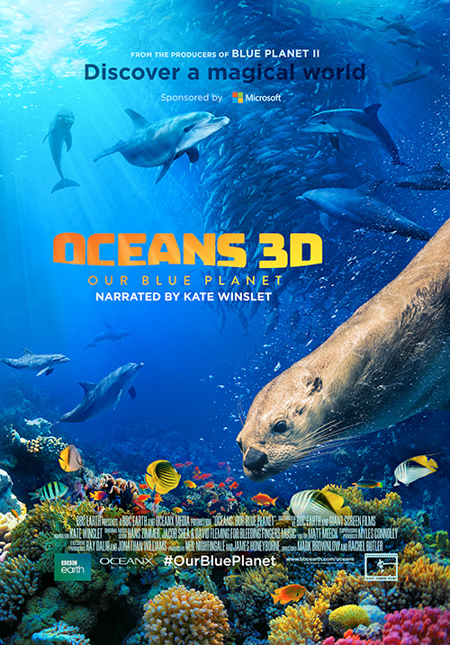

**Presentation:** Tennessee Aquarium: 3D; Dome Day at McWane Science Center: 15/70  
**Release:** March 16, 2018  
**Formats:** 2D and 3D, 15/70, DCI-compliant Digital, DCI-compliant Laser, IMAX Digital, IMAX Laser, Dome-customized 15/70, Fulldome Digital  
**Length:** 41:49 and 20:00 (41:49 at conference)  
**Producer:** BBC Earth and OceanX Media  
**Distributor:** Giant Screen Films and BBC Earth  
**Contact:** Mark Katz, [mkatz@gsfilms.com](mailto:mkatz@gsfilms.com)  
[www.bbcearth.com/oceans](http://www.bbcearth.com/oceans)

*Oceans: Our Blue Planet* takes us on a global odyssey to discover the largest and least explored habitat on earth. New ocean science and technology has allowed us to go further into the unknown than we ever thought possible. From the coastal shallows to deeper, more mysterious worlds, we reveal the untold stories of the oceans' most astonishing creatures. Dolphins leap for joy through the waves as we begin our journey into the blue. Our first stop is the coral reefs, where we meet fascinating characters like the ingenious tusk fish that uses a tool to open its food. In the great forests of the sea, we find a cunning octopus who shields herself in an armoury of shells to hide from predators. As we journey through our oceans, we share these extraordinary discoveries and uncover a spectacular world of life beneath the waves.

**Pandas**



**Presentation:** Tennessee Aquarium: 3D; Dome Day at McWane Science Center: 15/70  
**Release:** April 6, 2018  
**Formats:** 2D and 3D, 15/70, IMAX Digital, IMAX Laser, Dome-customized 15/70  
**Length:** 41:41  
**Producer/Distributor:** IMAX Corporation  
**Contact:** Gina Glen, [gglen@imax.com](mailto:gglen@imax.com), Doris Babiera, [dbabiera@imax.com](mailto:dbabiera@imax.com)  
[pandas.imax.com](https://pandas.imax.com/)

*Pandas*, an IMAX® original film for the whole family, is a story of hope, friendship and survival. At China’s Chengdu Panda Base, the scientist leading a successful captive breeding program is ready to take a bold new step. Inspired by the work of a black bear rehabilitator in New Hampshire, a team of U.S. and Chinese scientists collaborate on an innovative project to release captive-born pandas into the wild—using methods never previously tried with pandas. Captured with IMAX® Cameras, the film follows the journey of a young cub named Qian Qian as she leaves the comfort of the panda base behind and prepares for a life-changing journey into the misty mountains of Sichuan. *Pandas* is directed by David Douglas and Drew Fellman, the filmmakers behind *Born To Be Wild* and *Island Of Lemurs: Madagascar*. Fellman wrote and produced, with Douglas serving as director of photography.

**Planet Power**

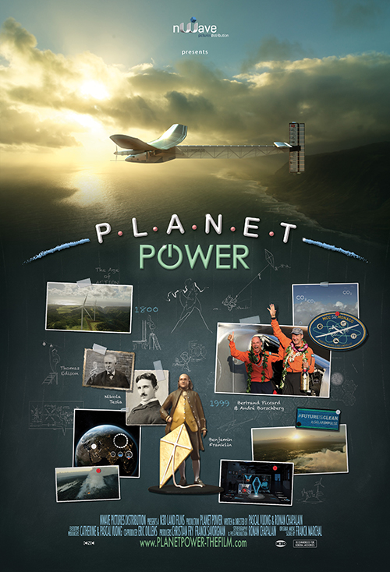

**Presentation:** Tennessee Aquarium: 3D; Dome Day at McWane Science Center: Digital  
**Release:** March 22, 2018  
**Formats:** 3D, DCI-compliant Digital, DCI-compliant Laser, IMAX Digital, IMAX Laser, Fulldome Digital  
**Length**: 40:42 and 20:31 (40:42 to screen at conference)  
**Producer**: N3D Land Films  
**Distributor:** nWave Pictures Distribution  
**Contact:** Janine S. Baker, Goedele Gillis, [info@nwave.com](mailto:info@nwave.com)  
[planetpower-thefilm.com](http://www.planetpower-thefilm.com)

*Planet Power* explores the history of electricity—from the first spark created by man’s hand to today’s industrial power plants. We meet scientists who changed the world, like Faraday, Franklin, and Tesla, and we glimpse the future as Solar Impulse becomes the first plane to complete a round-the-world flight powered only by the sun. With a mix of chalk animation, CGI, archival footage, and spectacular aerials, the film also explores the challenges ahead: how to meet the growing energy needs of our industrialized world, while also protecting the health of our planet.

**The Story of Earth**

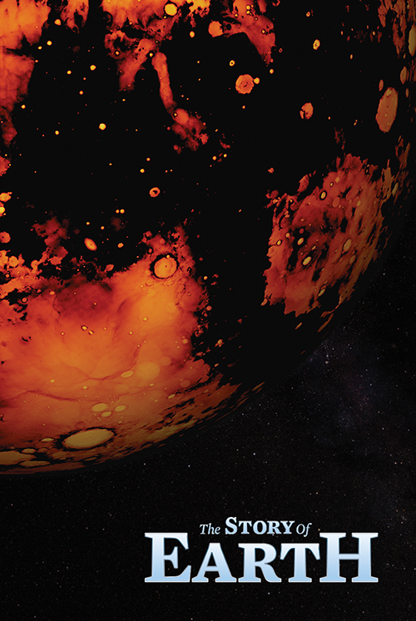

**Presentation:** Tennessee Aquarium: 3D; Dome Day at McWane Science Center: 15/70  
**Release:** May 2018  
**Formats:** 2D and 3D, 15/70, DCI-compliant Digital, IMAX Digital, IMAX Laser, D3D Digital Dome  
**Length:** 41:00 and 23:00 (41:00 at conference)  
**Producer:** December Media  
**Distributor:** December Media Distribution  
**Contact:** Mark Bretherton, [mark@decembermedia.com.au](mailto:mark@decembermedia.com.au)  
[thestoryofearth.film](http://thestoryofearth.film)

Born from dying stars, it was sculpted by violent collisions in space. Yet, in an epic journey, this hostile ball of molten rock transformed itself into a nurturing environment. From it emerged forms of life, none of which have been found anywhere else in the universe. That planet is not millions of light years away either. You are standing on it right now. It is Earth.

**Touch the Stars**

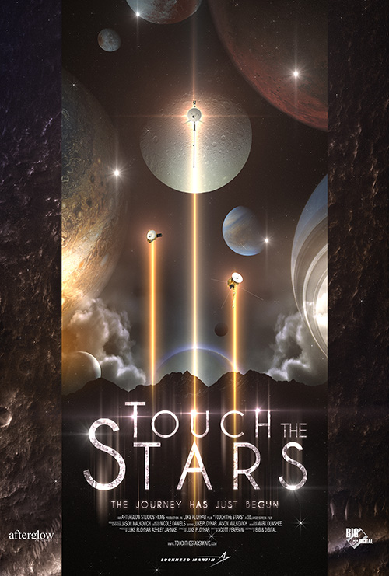

Rough/fine cut  
**Presentation:** Tennessee Aquarium 3D  
**Release:** November 2018  
**Formats:** 3D, 15/70, DCI-compliant Digital, DCI-compliant Laser, IMAX Digital, IMAX Laser, Dome-customized 15/70, Fulldome Digital  
**Length:** 25:00 and 40:00 (25:00 at conference)  
**Producer:** Afterglow Studios  
**Distributor:** BIG & Digital  
**Contact:** Tina Ratterman, [tratterman@biganddigital.com](mailto:tratterman@biganddigital.com)  
[www.touchthestarsmovie.com](http://www.touchthestarsmovie.com)

*Touch the Stars*centers on mankind’s probes used in exploration of our solar system and the galaxy beyond. The film traces the path to space through the history of NASA’s probes, orbiters, and landers, from the heart of our solar system to the surface of the other planets and moons, to the grand tour of the Voyager spacecraft through the outer planets and beyond. Created with the latest imagery and scientific data, *Touch the Stars* uses inspiring real footage and three-dimensional vistas of our solar system and interstellar space to transport audiences to planets and distant stars alongside these intrepid robot explorers. *Touch the Stars* will be released in stunning 8K resolution. We are presenting the 25-minute version at the conference but will release both 40-minute and 25-minute versions.

**Turtle Odyssey**

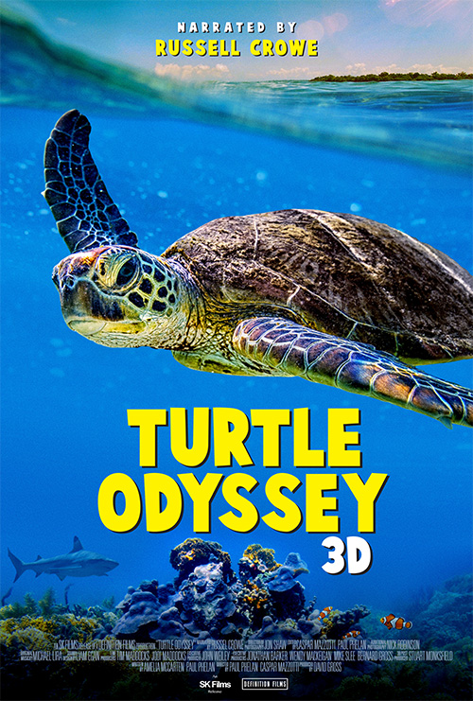

**Presentation:** Tennessee Aquarium: 3D  
**Release:** Summer 2018  
**Formats:** 2D and 3D, DCI-compliant Digital, DCI-compliant Laser, IMAX Digital, IMAX Laser, Dome-customized 15/70, Fulldome Digital  
**Length:** 42:00  
**Producer:** Definition Films  
**Distributor:** SK Films  
**Contact:** Amber Hawtin, [ahawtin@skfilms.ca](mailto:ahawtin@skfilms.ca)  
[turtleodysseyfilm.com](http://www.turtleodysseyfilm.com)

Sea turtles are some of Earth’s most ancient and majestic creatures. For over 100 million years, they have traversed the seas, enduring mass extinctions and playing critical roles in maintaining food webs. But now they face a new threat – humans. It’s time we learned more about these remarkable reptiles. Academy Award winner and turtle conservation champion Russell Crowe narrates the captivating tale of Bunji, a green sea turtle. From the moment her fragile egg cracks below the warm sands of an Australian beach, we join Bunji as she travels through the Great Barrier Reef and thousands of miles into open ocean. After decades, she will migrate with mysterious precision back to the very same beach where she was born and lay the eggs that are the foundation for the next generation. With Bunji as our guide, we will meet an astonishing range of strange and compelling creatures and witness some really wild encounters. All have been filmed in stunning 3D, so you will feel truly immersed amongst massive manta rays, breaching whales, and vibrant clownfish. Sea turtles remind us just how interconnected we all are, and audiences will be moved to cherish these beautiful and vulnerable animals even more.

**Volcanoes**

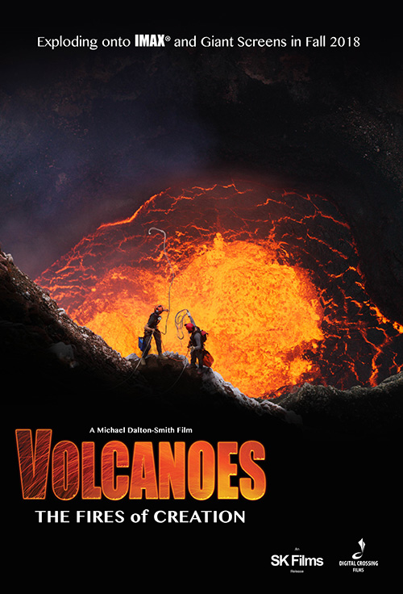

**Presentation:** Tennessee Aquarium: 3D; Dome Day at McWane Science Center: Digital  
**Release:** Fall 2018  
**Formats:** 2D and 3D, DCI-compliant Digital, DCI-compliant Laser, IMAX Digital, IMAX Laser, Dome-customized 15/70, Fulldome Digital  
**Length:** 42:00  
**Producer:** Digital Crossing Films  
**Distributor:** SK Films  
**Contact:** Amber Hawtin, [ahawtin@skfilms.ca](mailto:ahawtin@skfilms.ca)  
[www.volcanoesthemovie.com](http://www.volcanoesthemovie.com)

*Volcanoes - The Fires of Creation* is a tale of science, culture, and thrilling adventure. Earth is a planet born of fire. For billions of years, volcanoes have helped create the world we know. From the continents to the air we breathe and even life itself, all have their origins in fire. These processes have created extraordinary ecosystems and wildlife habitats. With over 500 active volcanoes, the Earth is bursting at the seams with these forces of mass construction. The story of volcanoes is the story of the planet’s creation, and the story of us. With explorer Carsten Peter, dodge boulders at the edge of an active volcano in Indonesia, descend to a lava lake in Vanuatu and visit the incredible mineral deposit fields in Ethiopia. Travel across the globe to see the archeological ghost town of Pompeii and witness the devastating effects of the recent Kilauea eruption in Hawaii. Audiences will be on the edge of their seats as they discover molten worlds and exploding craters in this adrenaline-filled, immersive experience that only IMAX®/Giant Screen films can provide.

**FILMS IN PRODUCTION**

### Ancient Caves

* **Release:** Fall 2019
* **Formats:** 2D, IMAX Digital, IMAX Laser, Dome-customized 15/70, Fulldome Digital
* **Length:** 45:00
* **Producer:** Oceanic Research Group, Inc.
* **Distributor:** MacGillivray Freeman Films
* **Contact:** Patricia Collins, [pcollins@macfreefilms.com](mailto:pcollins@macfreefilms.com)

Dr. Gina Moseley is a scientist on a mission as she travels the world exploring vast underground worlds in her quest to unlock the secrets of the Earth’s ancient climate in the most unlikely places: caves. Her need for underwater samples leads her to world-renowned cave diver Brian Kakuk. Brian can go where Gina can’t, and together they can reach places very few humans will ever go. Ancient Caves brings science and adventure together as the team embarks on an expedition to some of the world’s most extreme caves, both above and below the water, to learn how fast the climate can change, and how it has affected human civilization. Ancient Caves is being shot in dome-native format. Flat screen version will be available, and possible 3D release.

### Angkor: The Lost Empire of Cambodia

### Release: March 2019

* **Formats:** 2D and 3D, 15/70, DCI-compliant Digital, DCI-compliant Laser, IMAX Digital, IMAX Laser, Dome-customized 15/70, Fulldome Digital
* **Length:** 40:00
* **Producer:** Helio Projects Asia, Definition Films
* **Distributor:** K2 Communications
* **Contact:** Mark Kresser, [mark_kresser@k2communications.com](mailto:mark_kresser@k2communications.com)
* [k2communications.com](http://k2communications.com)

A civilization that rose to become the envy of the world, only to disappear—a mystery waiting to be unlocked by modern archaeologists, scientists, and explorers. Following an epic spree of religious building whose scale and ambition rivals the pyramids of Egypt, Angkor is the scene of one of the greatest vanishing acts of all time. The Khmer kingdom lasted from the 9th to the 15th centuries and at its height dominated a large swathe of South-East Asia from Myanmar to the west to Vietnam in the East. As many as one million people lived in Angkor, the capital, which sprawled across an area the size of New York's five boroughs, making it the most extensive urban complex of the pre-industrial world. By the late 16th century, the once resplendent capital of the empire, with its thousands of elaborate temples and religious monuments, was being overrun by the surrounding jungles. Many experts have attempted to provide answers, and theories abound. 1300 carved inscriptions survive on temple doorjambs but the Khmer people of Angkor left not a single word explaining their kingdom's collapse. This will be a visually stunning film—an epic adventure where science, mystery and ancient civilization intersect.

### Antarctica: A Year of Discovery

* **Release:** 2020
* **Formats:** 2D and 3D, DCI-compliant Digital, DCI-compliant Laser, IMAX Digital, IMAX Laser, Dome-customized 15/70
* **Length:** 40:00 and 20:00
* **Producer:** BBC Studios
* **Distributor:** BBC Earth
* **Contact:** Jonathan Williams, [jonathan.williams@bbc.com](mailto:jonathan.williams@bbc.com)
* [bbcearth.com](http://bbcearth.com)

Antarctica is the most extreme continent on our planet—higher, colder, and even drier than any other landmass on Earth, and although it is thousands of miles away, what happens here affects every single one of us. Temperatures can plummet to -70C, freezing its ocean waters, yet even in this remote, hostile habitat there is an abundance of life and beauty. Many creatures thrive above and beneath the ice, but exactly how do they survive in such an extreme environment? To answer that question, we will follow the story of a year in Antarctica, because more than anywhere else on our planet, life here is governed by the seasons. Only then can we discover how animals manage to survive in this hostile but beautiful land—Earth’s last great wilderness.

### Asteroid Impact

* **Release:** Fall 2019
* **Formats:** 2D and 3D, 15/70, IMAX Digital, IMAX Laser, Dome-customized 15/70
* **Length:** 40:00
* **Producer/Distributor:** IMAX Corporation
* **Contact:** Gina Glen, [gglen@imax.com](mailto:gglen@imax.com), Doris Babiera, [dbabiera@imax.com](mailto:dbabiera@imax.com)

Asteroid Impact will reveal the origins of asteroids and the effects of previous Earth impacts. Delve into how these celestial bodies have shaped life on primitive Earth and the threat they pose to our planet today. Learn how we monitor them in order to stay out of their deadly path. Through the eyes of scientists tasked with keeping watch over our planet, see the devastating effects of a hypothetical asteroid impact, portrayed on a grand scale as never seen before. The ways we might prevent a cosmic collision are also explored. This new IMAX documentary will make clear it’s not a question of if an asteroid will strike our planet again, but when.

### Back From the Brink

* **Release:** Fall 2019
* **Formats:** 2D and 3D, 15/70, DCI-compliant Digital, DCI-compliant Laser, IMAX Digital, IMAX Laser, Dome-customized 15/70, Fulldome Digital
* **Length:** 40:00
* **Producer:** Roam Pictures and Sean Casey
* **Distributor:** Cosmic Picture Distribution
* **Contact:** Antonietta Monteleone, [antonietta@cosmicpicture.com](mailto:antonietta@cosmicpicture.com)

Back from the Brink, from award-winning giant screen director Sean Casey, is an immersive film that will explore extraordinary true stories of animals rescued from the brink of extinction. Audiences will meet California’s endearing Channel Island Fox, the smallest canid in the world, imperiled by the introduction of Golden Eagles to their only habitat. We will witness the stunning migration of the Christmas Island Red Crabs, thinned dangerously by the Crazy Ant invasion. And, finally, we journey to Yunnan, China, to find the enigmatic Golden Monkey, high on the most-endangered primates list, living in one of the most biodiverse and remote regions of the world. Back from the Brink, with real and inspiring conservation stories, will renew your hope that our threatened planet and all its inhabitants can be saved.

### Expedition Chesapeake

* **Release:** March 20, 2019
* **Formats:** 2D, DCI-compliant Digital
* **Length:** 42:00
* **Producer:** Whitaker Center Productions, Inc., in association with Via Studios Global
* **Distributor:** Cosmic Picture
* **Contact:** Antonietta Monteleone, [antonietta@cosmicpicture.com](mailto:antonietta@cosmicpicture.com)
* [expeditionchesapeake.org](http://expeditionchesapeake.org)

Expedition Chesapeake, A Journey of Discovery, is an immersive expedition through the stunning beauty of Chesapeake Bay, the iconic watershed which stretches thousands of miles along America’s East Coast from New York to Virginia. Led by award-winning biologist and host of ABC’s Ocean Treks, Jeff Corwin, we will encounter the intricate and surprising web of plants, animals, people, land, and our most critical natural resource, water, and discover this region’s environmental success stories. Audiences will discover how seemingly small efforts can improve the health of Chesapeake Bay for all its inhabitants, and how these lessons can be applied in major waterways around the world.

### Fantastic Beasts: The Crimes of Grindewald

* **Release:** November 16, 2018
* **Formats:** 2D, IMAX Digital, IMAX Laser
* **Length:** TBD
* **Producer/Distributor:** Warner Bros.
* **Contact:** Gina Glen, [gglen@imax.com](mailto:gglen@imax.com)

Magizoologist Newt Scamander joins forces with young Albus Dumbledore to prevent the devious Gellert Grindelwald from raising pure-blood wizards to rule over all non-magical beings.

### First Man

* **Release:** October 12, 2018
* **Formats:** 2D, IMAX Digital, IMAX Laser
* **Length:** TBD
* **Producer/Distributor:** Universal Pictures
* **Contact:** Gina Glen, [gglen@imax.com](mailto:gglen@imax.com)

First Man is an upcoming American biographical adventure space film directed by Damien Chazelle based on the true story of NASA's mission to land a man on the moon, focusing on Neil Armstrong and the years 1961–1969.

### Ireland

* **Release:** 2020
* **Formats:** 2D and 3D, 15/70, DCI-compliant Digital, DCI-compliant Laser, IMAX Digital, IMAX Laser, Dome-customized 15/70, Fulldome Digital
* **Length:** 40:00
* **Producer/Distributor:** MacGillivray Freeman Films
* **Contact:** Patricia Collins, [pcollins@macfreefilms.com](mailto:pcollins@macfreefilms.com)

Ireland invites worldwide giant screen audiences on an extraordinary and joyful film adventure. Premiering in 2020, the Emerald Isle film celebrates Ireland’s rich history, land and seascapes, language, arts and music. A 40-minute showcase of the island nation’s natural beauty, Ireland also reaches for the soul of a country. Amid awe-inspiring locations such as Giant’s Causeway, Skellig Michael, and the Cliffs of Moher, the film follows Irish writer Manchán Magan on his quest to reconnect Irish people from around the world with their land, language, and stories. Premier violinist Patricia Treacey and four of her teen orchestra students join Manchán to lend an even greater insight into Irish traditions and culture through the lens of music. Along the way they’ll also meet scientists studying basking sharks and the adorable puffins of Skellig. From Dublin to Belfast, Kilkenny, Blarney Castle, and beyond, audiences will discover why they love Ireland.

### MFF's New Adventure Film

* **Release:** February 2020
* **Formats:** 2D and 3D, 15/70, DCI-compliant Digital, DCI-compliant Laser, IMAX Digital, IMAX Laser, Dome-customized 15/70, Fulldome Digital
* **Length:**40:00
* **Producer/Distributor:** MacGillivray Freeman Films
* **Contact:** Patricia Collins, [pcollins@macfreefilms.com](mailto:pcollins@macfreefilms.com)

A journey through time and place, this giant screen film will follow the trails made on land and sea that showcase our quest to explore our world. The film follows an adventurous Alaskan pilot and a space station astronaut, both Native Americans who share a passion to inspire the next generation to seek new experiences, discover math and science, and learn from history and other cultures. They’ll take audiences to spectacular locations, ancient homelands, hidden treasures and scenic byways, even into space.  As they honor the past and reach toward the future, the film connects audiences to the trailblazer in us all.

### Out of Bounds

* **Release:** Fall 2019
* **Formats:** 2D and 3D, 15/70, DCI-compliant Digital, DCI-compliant Laser, IMAX Digital, IMAX Laser, Dome-customized 15/70, Fulldome Digital
* **Length:** 40:00
* **Producer:** Wild Pacific Media and Definition Films
* **Distributor:** K2 Communications
* **Contact:** Mark Kresser, [mark_kresser@k2communications.com](mailto:mark_kresser@k2communications.com)
* [k2communications.com](http://k2communications.com)

Follow Australian Olympic gold medalist Torah Bright as she journeys along the great American Cordillera, the world’s longest chain of mountain ranges extending from Antarctica all the way to Alaska. On the journey, Torah will encounter world-class snow athletes, scientists, and environmentalists. Discover the crucial role mountains play in our ecosystem and everyday life, while witnessing the most spectacular snowboard and ski action ever brought to the giant screen!

### Science of Speed

* **Release:** Spring 2021
* **Formats:** 2D and 3D, DCI-compliant Digital, DCI-compliant Laser, IMAX Digital, IMAX Laser, Fulldome Digital
* **Length:** 40:00
* **Producer:** Elwha Films
* **Distributor:** To be announced
* **Contact:** Alex Charpentier, [alex@elwhafilms.com](mailto:alex@elwhafilms.com)

Science of Speed is science documentary with a racing soul, bringing you to 235 mph while showcasing STEM principles at work in the real world. Using relatable science, great personalities, and world-class CGI, it brings the thrill of chasing the winning edge to life. INDYCAR and team Penske (17-time INDY 500 winners) take you behind the scenes to learn how physics, engineering, the body, and brain work together with the car in the fight for every last thousandth of a second. The film will release with a custom pop-up exhibit allowing the audience to put the same concepts into practice themselves. An extensive STEM-based educational outreach program is currently in development to further expand upon the film’s platform and continue the conversation beyond the theater.

### Sea Lion: Life by a Whisker

* **Release:** Summer 2019
* **Formats:** 2D and 3D, 15/70, DCI-compliant Digital, DCI-compliant Laser, IMAX Digital, IMAX Laser, Dome-customized 15/70, Fulldome Digital
* **Length:** 40:00
* **Producer:** Definition Films
* **Distributor:** To be announced
* **Contact:** David Gross, [david@definitionfilms.com](mailto:david@definitionfilms.com)

Between a jagged cliff face and a roaring ocean, lives a colony of Australian Sea Lions. In an environment equally as harsh as it is beautiful, be immersed in a classic coming of age tale guided by one of Australia’s most unique, intelligent, and playful animals. Take an intimate journey inside the colony where a life of great intimacy, tenderness, and clumsiness, must often give way to a life of great sacrifice and bravery. Exposed to the elements, life here can be brutal and more dramatic than any scripted drama. The film will take audiences straight into the heart of one little family’s, big adventure. Exploring not only their connection to each other, but also to their environment. As one of the worlds most endangered marine mammals, it’s a never-before-seen struggle for survival, set against an astonishing and untouched wilderness.

### Secrets of the Sands

* **Release:** Spring 2019
* **Formats:** 2D and 3D, DCI-compliant Digital, DCI-compliant Laser, IMAX Digital, IMAX Laser
* **Length:** 40:00
* **Producer:** Atlantic Productions
* **Distributor:** Serengeti Entertainment
* **Contact:** Melissa Williams, [melissaw@serengetientertainment.co.uk](mailto:melissaw@serengetientertainment.co.uk)

Secrets of the Sands tells the tale of how an ancient people gained a remarkable mastery over one of the most inhospitable landscapes on the planet. This is a captivating human story that stretches back over 125,000 years. With breathtaking animations, CGI reconstructions, and present-day archaeology, we’ll follow these people through the Stone Age, Bronze Age, Iron Age, and beyond, witnessing the incredible innovations that marked humans’ earliest progress through history. From creating tools from copper and taming wild animals, to engineering ancient cities and man-made oases in the desert, this is a universal story of humanity—the ultimate tale of triumph over adversity.

### Secrets of the Universe

* **Release:** April 2019
* **Formats:** 2D and 3D, 15/70, DCI-compliant Digital, DCI-compliant Laser, IMAX Digital, IMAX Laser, Dome-customized 15/70, Fulldome Digital
* **Length:** 40:00
* **Producer:** The Stephen Low Company
* **Distributor:** K2 Communications
* **Contact:** Mark Kresser, [mark_kresser@k2communications.com](mailto:mark_kresser@k2communications.com)
* [k2communications.com](http://k2communications.com)

We are at the beginning of a period of unprecedented technological advancement, catalyzing a new age of scientific discovery. Travel with us on this immersive giant screen film as we explore the most exciting machines ever conceived by man, including the Large Hadron Collider and James Webb Space Telescope. See how these new experiments allow us to look deeper into our origins, and unveil the mysteries of dark energy, dark matter, and extra dimensions.

### Super Science Showcase

* **Release:** September 29, 2018
* **Formats:** 2D, DCI-compliant Digital, Fulldome Digital
* **Length:** 45:00
* **Producer:** Wonder Mill Cosmos
* **Distributor:** BIG & Digital
* **Contact:** Tina Ratterman, [tratterman@biganddigital.com](mailto:tratterman@biganddigital.com)
* [superscienceshowcase.com](http://superscienceshowcase.com)

Super Science Showcase is an exciting collection of five educational adventure stories, perfect for middle school audiences and great for all ages. Featuring memorable plots and unique characters, these five stories also teach an introduction to scientific topics (in line with National Education Standards) that include the Laws of Motion; Astronomy; Animal Classification; States of Energy; and the Scientific Method. The film is available in both Standard and Interactive versions; Interactive versions include a pause for an audience quiz question near the end of each adventure, and a possible alternate ending, depending on the answer selected by the audience. This anthology film is also customizable for different theater needs, and available in shorter versions, in custom arrangements, or as individual episodes. The film's release is alsoaccompanied with a strong peripheral collection of multimedia tie-ins, including books, merchandise and an App, also available in September, and will be coming to fulldome in 2019, with specific sequences shot just for dome screens.

### Superpower Dogs

* **Release:** March 15, 2019
* **Formats:** 2D and 3D, 15/70, DCI-compliant Digital, DCI-compliant Laser, IMAX Digital, IMAX Laser, Dome-customized 15/70, Fulldome Digital
* **Length:** 40:00
* **Producer:** Cosmic Picture
* **Distributor:** IMAX and Cosmic Picture
* **Contact:** Gina Glen, [gglen@imax.com](mailto:gglen@imax.com); Doris Babiera, [dbabiera@imax.com](mailto:dbabiera@imax.com); Antonietta Monteleone, [antonietta@cosmicpicture.com](mailto:antonietta@cosmicpicture.com); John Wickstrom, [john@cosmicpicture.com](mailto:john@cosmicpicture.com)

Join an immersive IMAX adventure to experience the life-saving superpowers and extraordinary bravery of some of the world’s most amazing dogs. In this inspiring true story, our best friends are also real-life superheroes. Journey around the globe to meet remarkable dogs who save lives and discover the powerful bond they share with their human partners. Follow Halo, a rookie puppy training to join one of the most elite disaster response teams in America. Meet Henry, an avalanche rescue expert in the Canadian Rockies; Reef, a Newfoundland lifeguard with the Italian coastguard; Ricochet, a Californian surf legend helping people with special needs; and the Bloodhound brothers, Tipper and Tony, who are leading the fight to save endangered species in Africa. As we discover the incredible abilities of dogs and the astonishing science behind their superpowers, we’ll never look at our best friends the same way again!

### Treasures of Mount Sinai

* **Release:** 2019-2020
* **Formats:** 2D and 3D, 15/70, DCI-compliant Digital, DCI-compliant Laser, IMAX Digital, IMAX Laser, Dome-customized 15/70, Fulldome Digital
* **Length:** 40:00
* **Producer:** Mount Sinai Project
* **Distributor:** To be announced
* **Contact:** Nick Pithis, [nick@mountsinaiproject.com](mailto:nick@mountsinaiproject.com)
* [mountsinaiproject.com/](http://mountsinaiproject.com/)

Treasures of Mount Sinai is a journey to the mountain where Moses received the Ten Commandments, and discover why historical figures like Napoleon, Ivan the Terrible, and Emperor Justinian sought to protect it. Join an exciting adventure through St. Catherine’s Monastery in the Egyptian desert where you will follow a group of young students as they embark on the journey of a lifetime. Learn how this unique environment has contributed to the preservation of many treasures that has stood the test of time for over 1500 years. Uncover the wonders within the monastery walls and immerse yourself in a world never before seen on film. No film crew has ever gained this level of access to the secrets hidden within the monastery.

### Wingsuit Flyers

* **Release:** Fall 2018
* **Formats:** 2D and 3D, 15/70,DCI-compliant Digital, DCI-compliant Laser, IMAX Digital, IMAX Laser, Dome-customized 15/70, Fulldome Digital
* **Length:** 40:00
* **Producer:** Grand Schema
* **Distributor:** K2 Communications
* **Contact:** Mark Kresser, [mark_kresser@k2communications.com](mailto:mark_kresser@k2communications.com)
* [k2communications.com](http://k2communications.com)

The dream of flying has captivated human imagination since prehistoric times. Even with the advent of aircrafts and the increasing availability of air travel, the ancient question stays with us: What if we could simply spread our arms and fly like a bird? Wingsuit flight is a groundbreaking phenomenon that has adrenaline junkies travelling the world in search of one exhilarating experience after the next. Our flyers have set records searching out the most exciting locations to take longer and more daring flights. In this epic 40-minute IMAX experience, we catch a ride with some of the best flyers in the world as they journey to incredible mountaintops while teaching us the art and science of human flight. The film is both a first- and third-person perspective from the flyers themselves and a name Voice Over. It will feature incredible footage from POV helmet cameras, flying drones, and helicopter rigs. What’s behind the pilot and the suit? How can they fly longer and faster? Will man ever fly without a chute? We answer those questions and more while exploring the burgeoning counter culture of wingsuit pilots, whose lives are dedicated to chasing the thrill and pursuit of human flight.

**PROJECTS IN DEVELOPMENT**

### Blue Whales

* **Release:** March 2021
* **Formats:** 2D and 3D, 15/70, DCI-compliant Digital, DCI-compliant Laser, IMAX Digital, IMAX Laser, Dome-customized 15/70, Fulldome Digital
* **Length:** 40:00
* **Producer:** Oceanic Films Ltd.
* **Distributor:** To be announced
* **Contact:** Hugh Pearson, [hugh@oceanicfilms.tv](mailto:hugh@oceanicfilms.tv)
* [oceanicfilms.tv](http://www.oceanicfilms.tv)

Blue whales grow to 100 foot long and have a heart the size of a car yet despite their great size we know surprisingly little about them. With new scientific discoveries and the latest filming techniques we can now reveal the secret lives of blue whales, in a story made for the giant screen. We will follow a team of passionate scientists using the latest tech and “old fashion” science to reveal the blue whales’ epic migrations and intimate birthing grounds. In Mexico’s stunning Gulf of California and off the coast of Southern California we will film blue whales as never before. Come with us as we discover the mysteries of the largest animal that has ever lived, shown in life size on the giant screen—a truly awe-inspiring experience. Blue whales—the intimate story of an iconic character in an epic location. Oceanic Films are pleased to team up with Myles Connolly as supervising producer on this film. Myles is a 25-year giant screen veteran and has collaborated on more than 40 award-winning and Oscar-nominated films.

### Cool Cities

* **Release:** Late 2019
* **Formats:** 2D and 3D, 15/70, DCI-compliant Digital, DCI-compliant Laser, IMAX Digital, IMAX Laser, Dome-customized 15/70, Fulldome Digital
* **Length:** 40:00
* **Producer:** Wild Pacific Media and Definition Films
* **Distributor:** K2 Communications
* **Contact:** Mark Kresser, [mark_kresser@k2communications.com](mailto:mark_kresser@k2communications.com)
* [k2communications.com](http://k2communications.com)

Cool Cities is an immersive global journey that explores how science and technology together with a cultural renaissance are opening the door to a sustainable future in many of the world’s most iconic mega-cities. The film will offer a practical vision for more livable cities that all people of all continents can connect with and be part of. We will showcase the human stories and real solutions that provide hope for a planet that cannot only survive, but thrive for countless generations to come.

### Dinosaurs of Antarctica

* **Release:** 2020
* **Formats:** 2D and 3D, 15/70, DCI-compliant Digital, DCI-compliant Laser, IMAX Digital, IMAX Laser, Dome-customized 15/70
* **Length:** 40:00 and 20:00
* **Producer/Distributor:** Giant Screen Films
* **Contact:** Mark Katz, [mkatz@gsfilms.com](mailto:mkatz@gsfilms.com)

Journey to the south polar landscapes of Earth 100 million years ago, a world of primitive forests and thick swamps—populated by bizarre dinosaurs and colossal amphibians. Enter a surreal world of Permian and Triassic bug-eyed giants and egg-laying mammals—where survival meant enduring the sunless, six-month polar winter surrounded by meat-eaters with night vision. Join Antarctic scientists on a quest to understand Earth at a time of great climatic and geologic upheaval… and to unravel the mystery behind the largest extinction in the history of our planet. Major funding provided by the National Science Foundation.

### Einstein’s Incredible Universe

* **Release:** 2020
* **Formats:** 2D and 3D, 15/70, DCI-compliant Digital, DCI-compliant Laser, IMAX Digital, IMAX Laser, Dome-customized 15/70, Fulldome Digital
* **Length:** 40:00
* **Producer:** Cosmic Picture
* **Distributor:** Cosmic Picture Distribution
* **Contact:** Antonietta Monteleone, [antonietta@cosmicpicture.com](mailto:antonietta@cosmicpicture.com)
* [Cosmicpicture.com](http://Cosmicpicture.com)

Today Albert Einstein is regarded as the most famous scientist of all time, his name shorthand for genius, yet few of us fully understand his discoveries and their impact on our lives. Now through a combination of stunning live-action cinematography and immersive CGI, audiences will experience first-hand the visceral "thought experiments" at the heart of Einstein's radical new vision of the universe. Along the way, we will come to appreciate how so many innovations we take for granted stem from his imagination and how his General Theory of Relativity remains the basis of nearly every current theory about how the cosmos works, from black holes and time travel to the recent discovery of gravitational waves.

### Extreme Earth

* **Release:** January 18, 2020
* **Formats:** 2D and 3D, 15/70
* **Length:** 45:00
* **Producer:** Various
* **Distributor:** To be determined
* **Contact:** Ross Asdourian, [ross.asdo@gmail.com](mailto:ross.asdo@gmail.com)

Extreme athletes stunt on a disappearing planet in the first-ever multi-disciplinary environmental action sports film. This narrated feature takes you on a visual journey through surf, swim, and snow with a diverse range of the sport’s most influential competitors. Filming will be in Hawaii, a state home to 11 of the 13 existing climate zones, and act as a microcosm for the planet's current challenges. Fly in the wind, carve down a mountain, and dive with the sharks. Each scene breaks down the sport science that an athlete needs to perform in Mother Nature's shifting conditions. Extreme Earth is 80% stoke and 20% awareness, giving an adrenaline rush to a planet full of adventure.

### Giant Machines

* **Release:** To be determined
* **Formats:** 2D and 3D, 15/70, DCI-compliant Digital, DCI-compliant Laser, IMAX Digital, IMAX Laser, Dome-customized 15/70
* **Length:** 40:00 and 20:00
* **Producer/Distributor:** Giant Screen Films
* **Contact:** Mark Katz, mkatz@gsfilms.com

Smash! Crunch! Dig! A giant screen, full-throttle ode to the bulldozers and machines that build (and demolish) our world. For the kids!

### Leonardo da Vinci

* **Release:** 2019
* **Formats:** 2D and 3D, 15/70, DCI-compliant Digital, DCI-compliant Laser, IMAX Digital, IMAX Laser, Dome-customized 15/70, Fulldome Digital
* **Length:** 40:00
* **Producer:** Camera Lucida Productions
* **Distributor:** MacGillivray Freeman Films
* **Contact:** Patricia Collins, [pcollins@macfreefilms.com](mailto:pcollins@macfreefilms.com)

Camera Lucida and MacGillivray Freeman Films are once again joining forces to produce a giant screen film on the ultimate renaissance man–Leonardo da Vinci. From the award-winning Director of Van Gogh: Brush with Genius, François Bertrand, and for the 500th anniversary of Leonardo da Vinci’s death, with astonishing visual effects da Vinci’s works will be brought to the giant screen for the first time. The film will bring to life the breadth and depth of da Vinci’s genius with an artistic view of his drawings and sketches, his research on human anatomy and his engineering projects. The work of da Vinci would revolutionize the world forever.

### Ocean 3D

* **Release**: 2020
* **Formats**: 3D, DCI-compliant Digital, DCI-compliant Laser, IMAX Digital, IMAX Laser, Fulldome Digital, 15/70 if appropriate
* **Length**: 45:00
* **Producer**: Principal Large Format and Vulcan Productions
* **Distributor**: To be determined
* **Contact**: Phil Streather, [phil@plf.cc](mailto:phil@plf.cc)
* [www.plf.cc](http://www.plf.cc)

Ocean 3D (previously Planet Ocean 3D) is a film about the real-life heroines and heroes who use science, ingenuity, and collective action to address the big issues that threaten marine environments around the world. Center stage is the ocean as an interconnected life-supporting system, host to awe-inspiring biodiversity, but now at risk because of climate change, overfishing and run-away pollution. Audiences will come away educated, entertained and, most importantly, inspired to action. STOP PRESS:  
Wild Ocean/Last Reef/Great White helmer Luke Cresswell has come on board as writer/director and we look forward to sharing exciting news about the state of financing for this film.

### Ocean Giants

* **Release:** 2020
* **Formats:** 2D and 3D, 15/70, DCI-compliant Digital, DCI-compliant Laser, IMAX Digital, IMAX Laser, Dome-customized 15/70
* **Length:** 40:00 and 20:00
* **Producer/Distributor:** Giant Screen Films
* **Contact:** Mark Katz, [mkatz@gsfilms.com](mailto:mkatz@gsfilms.com)

Blue whales are the largest animal ever to live on planet Earth, including the dinosaurs. The transition over millions of years from fish to land mammal is one of life’s most astounding transformations. The return of mammalian life from land to sea—a 40-million year epic—is equally profound. Join intrepid paleontologist adventurers on a giant screen journey to otherworldly ancient seas. Discover one of the most illustrative evolution stories—through the extraordinary Age of Mammals—tracing the early land-dwelling, wolf-like cetaceans to the ocean giants of today.

### The Planets: Our Next Century in Space

* **Release:** 2020
* **Formats:** 2D and 3D, 15/70, DCI-compliant Digital, DCI-compliant Laser, IMAX Digital, IMAX Laser, Dome-customized 15/70, Fulldome Digital
* **Length:** 40:00
* **Producer:** Giant Screen Films and K2 Communications
* **Distributor:** K2 Communications
* **Contact:** Mark Kresser, [mark_kresser@k2communications.com](mailto:mark_kresser@k2communications.com)
* [K2communications.com](http://K2communications.com)

From moon bases and space elevators to asteroid outposts and aerostatic habitats, Planets will profile the dreamers of today, whose proof-of-concept technologies and mind-blowing innovations may one day allow our children’s children to push ever deeper into a solar system both beautiful and bizarre. Co-produced and co-distributed by Giant Screen Films and K2 Communications.

### Shark Rescue

* **Release:** 2020
* **Formats:** 2D and 3D, DCI-compliant Digital, IMAX Digital, IMAX Laser, Dome-customized 15/70
* **Length:** 42:00
* **Producer:** December Media and Sea Light Pictures
* **Distributor:** December Media Distribution
* **Contact:** Mark Bretherton, [mark@decembermedia.com.au](mailto:mark@decembermedia.com.au)

Humans don’t need rescuing from sharks, it’s sharks that need rescuing from humans. Meet Madi Stewart, a young, passionate shark advocate, on a mission to save sharks from humans—their most fearsome predator. Travel with Madi from Australia’s Great Barrier Reef to a remote island in Indonesia as she works with local villagers to transform their way of life from shark fishing to shark tourism. Madi wants to change the way we think about sharks. What better place to start than underwater? Come meet them face to face in this immersive 3D adventure.

### Sharks: The Apex Predator

* **Release:** Late 2019
* **Formats:** 2D and 3D, 15/70, DCI-compliant Digital, DCI-compliant Laser, IMAX Digital, IMAX Laser, Dome-customized 15/70, Fulldome Digital
* **Length:** 40:00
* **Producer:** Definition Films
* **Distributor:** K2 Studios
* **Contact:** Mark Kresser, [mark_kresser@k2communications.com](mailto:mark_kresser@k2communications.com)
* [K2communications.com](http://www.k2communications.com)

Sharks are the perfect apex predator, unchanged and untouched by time. Our species’ histories converge at the intersection of fascination and fear. Sharks (WT) will take audiences on scientific journey of discovery into their world of the deep abyss as we seek to understand and respect this amazing ruler of the sea.

### Shipwrecks

* **Release:** To be determined
* **Formats:** 2D and 3D, 15/70, DCI-compliant Digital, DCI-compliant Laser, IMAX Digital, IMAX Laser, Dome-customized 15/70
* **Length:** 40:00 and 20:00
* **Producer/Distributor:**Giant Screen Films
* **Contact:** Mark Katz, mkatz@gsfilms.com

From pirate treasures to sunken galleons and battleships in tropical lagoons. Join a team of modern explorers to seek and dive the world’s shipwrecks, relics lost to sea.

### Tiger, Tiger

* **Release:** Fall 2019
* **Formats:** 2D and 3D, 15/70, IMAX Digital, IMAX Laser, Dome-customized 15/70
* **Length:** 40:00
* **Producer/Distributor:** IMAX Corporation
* **Contact:** Gina Glen, [gglen@imax.com](mailto:gglen@imax.com)

The tiger, the biggest of the big cats, is one of the most powerful animals to stride our planet and also one of the most threatened by extinction. Alan Rabinowitz, the leading big cat conservation scientist of our time, ventures deep into the mangrove forests of India and Bangladesh seeking the little-known Sunderbans tiger. As he journeys through the remote river-forest and the villages that surround it, Alan encounters both the threats the tiger faces, and the solutions that can save it. Evoking his own childhood vow to be a voice for animals, Alan shows how ordinary people can become “tiger heroes.” And casting a thrilling shadow over all the action is the magnificent, incomparable tiger.

### Yellowstone: Life in Extremes

* **Release:** 2020
* **Formats:** 3D, DCI-compliant Digital, DCI-compliant Laser, IMAX Digital, IMAX Laser, Fulldome Digital
* **Length:** 40:00
* **Producer/Distributor:** Grizzly Creek Films
* **Contact:** Thomas Winston, [tom@grizzlycreekfilms.com](mailto:tom@grizzlycreekfilms.com)
* [grizzlycreekfilms.com](http://grizzlycreekfilms.com)

For centuries, a single place in North America has captured the world’s imagination: Yellowstone. But the world’s first National Park has never before been experienced like this. Follow nature’s epic drama as a struggle for survival unfolds in three dimensions. The stage is set a place like no other: a place where the world’s largest active supervolcano fuels the biggest collection of geothermal features anywhere on earth, a place where subzero temperatures and record snowfall dictate harsh trials in a stunning, frozen wonderland, a place where North America’s richest ecosystem offers a rare glimpse into the continent’s wild past. Filmed for two straight years, Yellowstone: Life in Extremes is the most ambitious giant screen production ever attempted in the iconic national park. And, once again, the whole world will be watching.